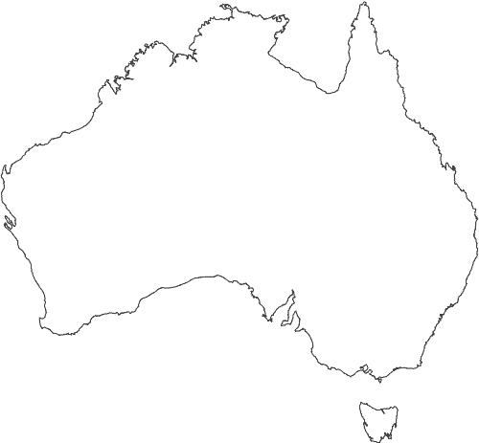
Perth
●
●
Darwin
●
Cairns
●
Sydney
●
Melbourne
●
Ayers Rock
Highway
Rail road
Tasmania

